**DEVELOPMENT OF AN AN ONLINE SHOPPING SYSTEM**

**Developed by**

Shohel Pramanik

**0121150110050**

Report submitted to Lincoln University College Training Centre, Main Campus Wisma Lincoln, No. 12, 14, 16 & 18, Jalan SS 6/12, 47301 Petaling Jaya, Selangor Darul Ehsan, Malaysia.

September, 2017

**DECLARATION**

I am **Shohel Pramanik**, with student ID: **0121150110050,** hereby declare that the project was done by me and all the content therein are of my own fabrication.

----------------------------  
**Signature & Date**

**CERTIFICATION**

Thisreport wassubmitted to Lincoln University College Training Centre and it has been accepted as a fulfilment of the requirement for the level advancement in the Software Development/ Network and Server training. The members of the evaluation committee were as follows:

1. **Deputy Registrar/Head of Training Centre**

Name: **Murtadho M. Alao**

Signature and Date:

1. **Software Development Lecturer**

Name: **Dr. Munir Kolapo Yahya-Imam**

Signature and Date:

1. **Network and Server Lecturer**

Name: **Aashu Jha**

Signature and Date:

**ABSTRACT**

An online shopping system that permits a customer to submit online orders for items and/or services from a store that serves both walk-in customers and online customers. The online shopping system presents an online display of an order cut off time and an associated delivery window for items selected by the customer. The system accepts the customer's submission of a purchase order for the item in response to a time of submission being before the order cut off time. The online shopping system does not settle with a credit supplier of the customer until the item selected by the customer is picked from inventory but before it is delivered. Therefore, the customer can go online and make changes to the order. In addition, available service windows are presented to the customer as a function of customer selected order and service types and further, the order picking is assigned in accordance with a picker's preference. When ordering goods, many shopping systems provide a virtual shopping cart for holding items selected for purchase. Successive items selected for purchase are placed into the virtual shopping cart until a customer completes their shopping trip. Virtual shopping carts may be examined at any time, and their contents can be edited or deleted at the option of the customer. Once the customer decides to submit a purchase order, the customer may print the contents of the virtual shopping basket order to obtain a hard copy record of the transaction.**INTRODUCTION**

Anything that customers purchases affects environment by means of delivery, whether they have the product shipped at home or drive to a brick and mortar store(supermarket). In earlier days people used to go to different shops before purchasing as they didn't have a great deal of easy access to information on products. Due to the development of World Wide Web it has now become easy to access the products available worldwide without wasting time, money and other resources apart from helping environment. Centre for Energy and Climate Solutions suggests that we can protect land and save energy by shopping online.

An online shopping system that permits a customer to submit online orders for items and/or services from a store that serves both walk-in customers and online customers. The online shopping system presents an online display of an order cut off time and an associated delivery window for items selected by the customer. The online shopping system does not settle with credit supplier of the customer until the item selected by the customer is picked from inventory but before it is delivered.

**METHODOLOGY**

Select Project Topic

Plan of the Project

Hardware Tools

Software Tools

Project Requirements

Develop the Project

Test

Presentation

Documentation

**Figure 1: Methodology Framework**

**Select Project Topic**

When it seems that the entire world is making it online be it marketing or exposure, online shopping lags no behind it either. Be it for your business or for your personal self online shopping is the way to go for there are various benefits to it. And then this project came infront of me.

**Planning**

After selection this project, it was so important about planning of this project.

- What is the requirements for this project

- How many days it will take

- How to develop this system etc.

- Documetation for the project

**Software tools**

This Online Shopping system project has done on Visual Studio platform using C# language. Mongodb, Sql and Microsoft Access database are used.

**Hardware tools**

To do this project are used

-Windows 7 Proffessional

-500 GB HDD, 4 GB RAM

-2.41 GHz Processor.

-64 bit operating system

**DESIGN AND IMPLEMENTATION**

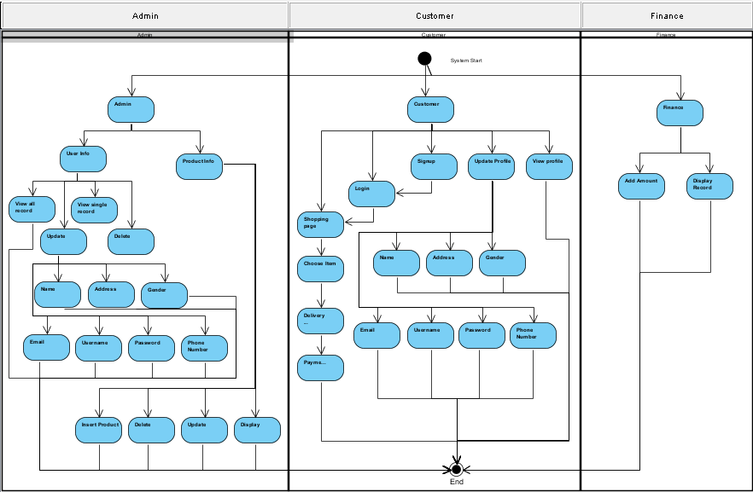

**Figure 2: System Diagram**

In this system will start to display menu page for Admin, Users and Finace.According to this system

1. Admin
   1. User info
      1. View all users record
      2. View single user records
      3. Update users  
         1.1.3.1 Name  
         1.1.3.2 Address  
         1.1.3.3 Gender  
         1.1.3.4 Email  
         1.1.3.5 Username  
         1.1.3.6 Password  
         1.1.3.7 Phone Number
      4. Delete users
   2. Product info
      1. Insert/Add product
      2. Delete
      3. Display
      4. Update
2. User
   1. Shopping page
   2. Login
   3. Signup & login
   4. Update profile  
       2.4.1 Name  
       2.4.2 Address  
       2.4.3 Gender  
       2.4.4 Email  
       2.4.5 Username  
       2.4.6 Password  
       2.4.7 Phone Number
   5. View profile
3. Finance
   1. Add amount
   2. Display record

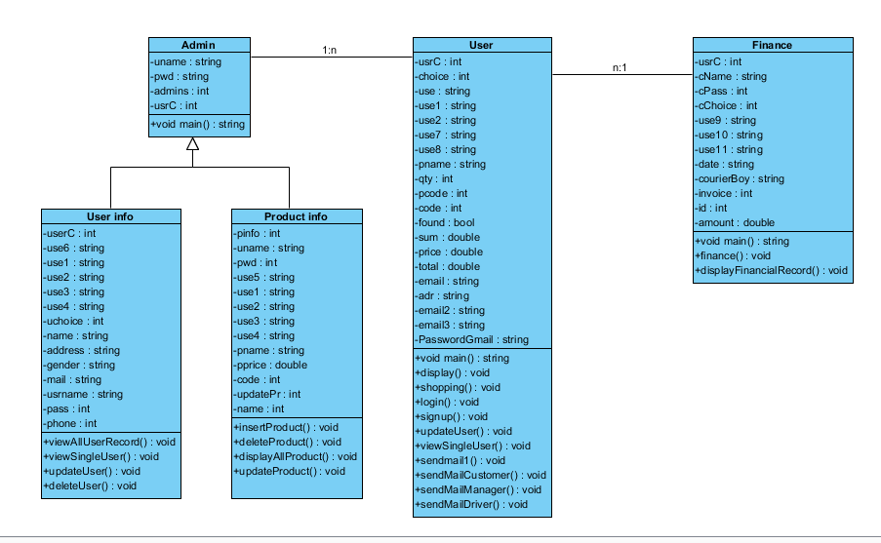

**Figure 3: Class Diagram**

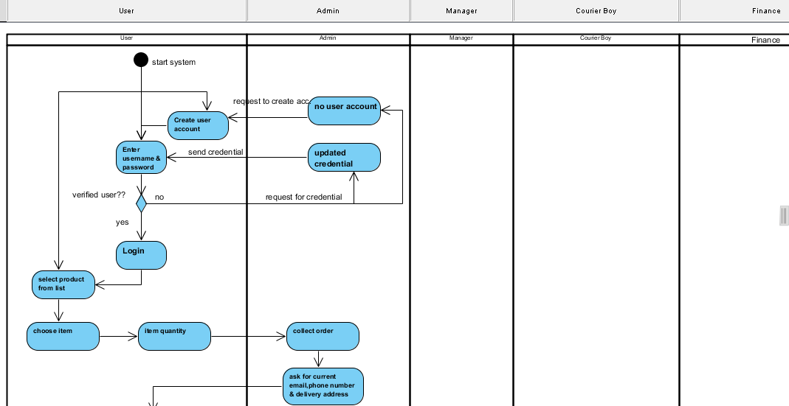

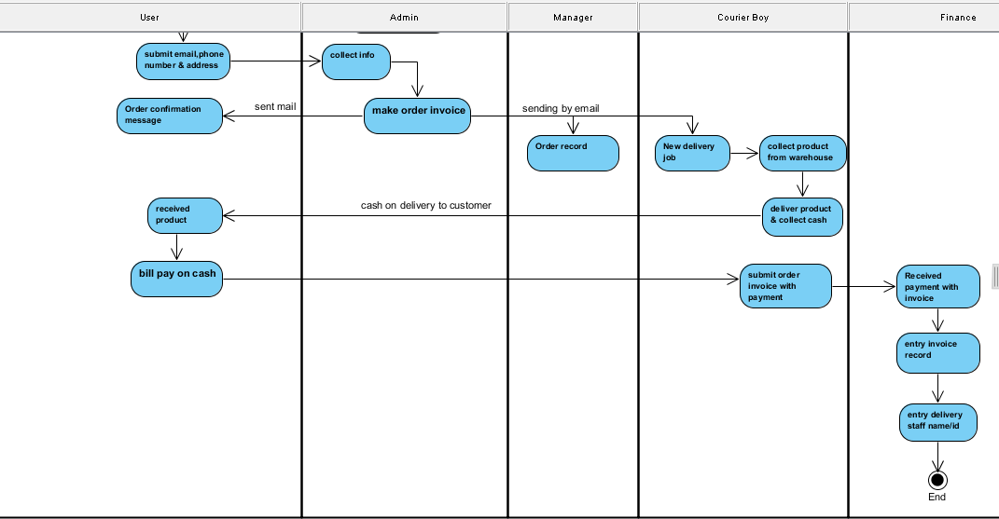

**Figure 4: Activity Diagram**

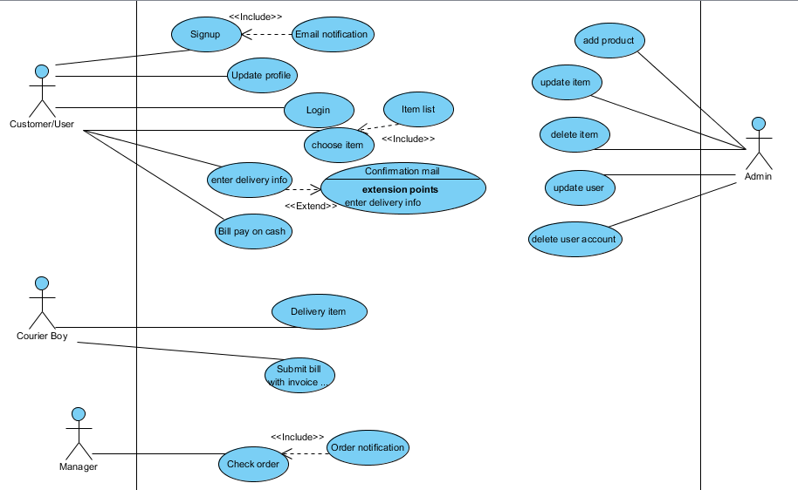

**Figure 5: Use Case Diagram**

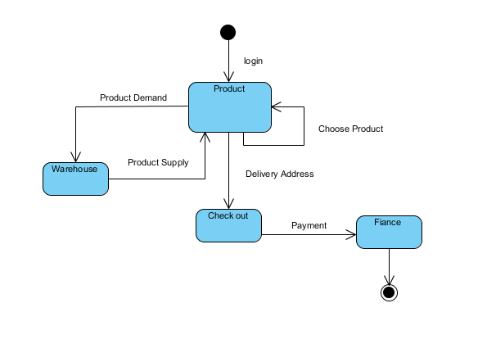

**Figure 6: State Machine Diagram**

Use Case: User create/Signup

Primary Actors: Customer

Precondition: Network connection is active.

Basic flows:

1. Request for user creation

2. System ask for User valid information

3. Customer submit requirement

4. Customer will get user confirmation email.

Alternate flows:

1. User will get notification by mail after submit information, If email id become wrong than user will never get login information.
2. User have to create account again.

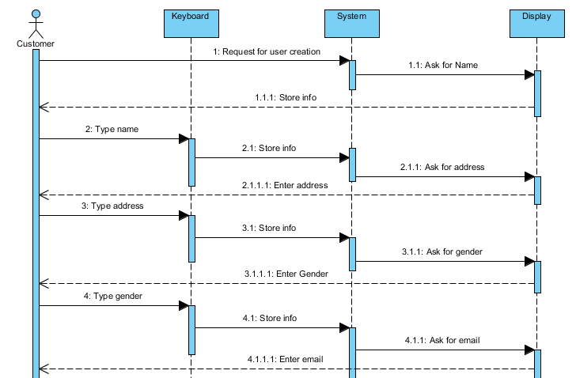

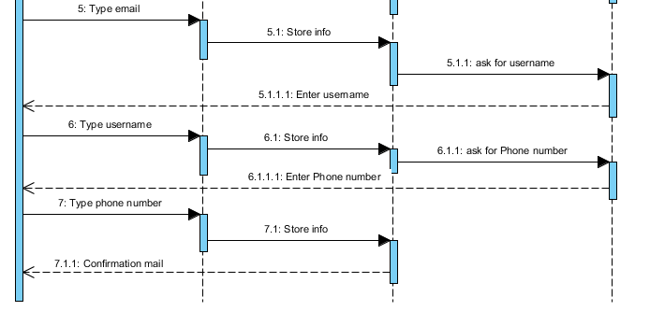

**Figure 7.1: Signup Sequence Diagram**

Use Case: Update User profile

Primary Actors: Customer

Precondition: Network connection is active.

Basic flows:

1. Customer request for update profile information

2. System display update menu

3. Customer can update any information of his/her profile

4. System will show updated profile

Alternate flows:

1. If user enter wrong username to update any information, system won’t generate. It will ask again to login than you can update information.

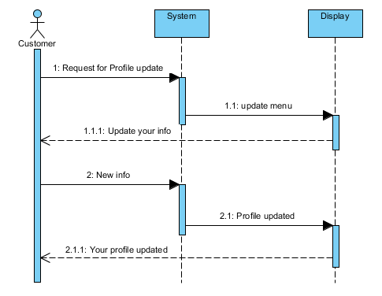

**Figure 7.2: Update Sequence Diagram**

Use Case: Login

Primary Actors: Customer

Precondition: Network connection is active.

Basic flows:

1. System ask for username

2. Customer submit username

3. System ask for password

4. Customer submit valid password for login

Alternate flows:

1. If username and password both or any one is going wrong system will reply to enter username & password again.

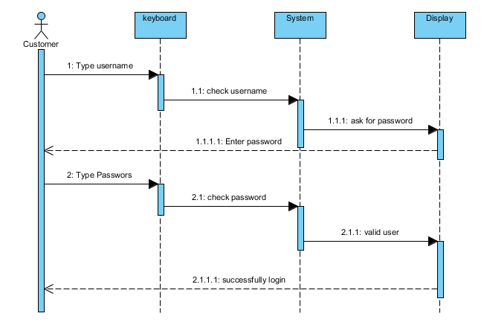

**Figure 7.3: Login Sequence Diagram**

Use Case: Item Selection

Primary Actors: Customer

Precondition: Network connection is active.

Basic flows:

1. Customer choose product using product code

2. System ask for quantity

3. Customer gives quantity

4. System will ask for more purchase

5. System will ask for delivery address

6. Customer will give delivery address

7. System will send receipt to customer by email

Alternate flows:

1. If user enter wrong product code than system will request to enter correct product code.
2. If user enter any wrong delivery information than system can’t catch that.

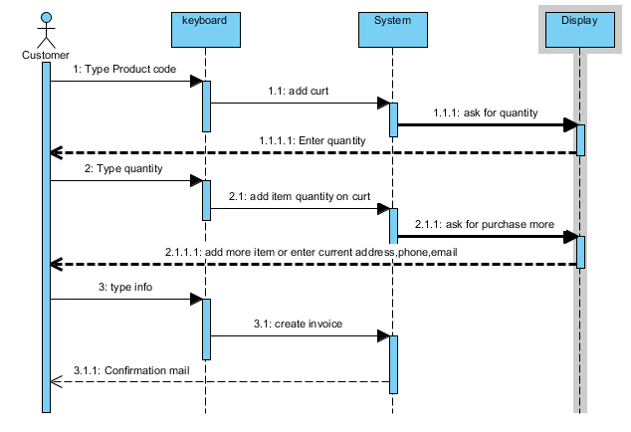

**Figure 7.4: Item Selection Sequence Diagram**

Use Case: Delivery information

Primary Actors: Customer

Precondition: Network connection is active.

Basic flows:

1. Customer Select purchasing item

2. System will ask for delivery address

3. Customer submit delivery address with active email address

4. System will send email to Customer for confirmation

Alternate flows:

1. If delivery address is going wrong than customer have to collect from ware house.
2. If email address is wrong than customer never get email confirmation notification.

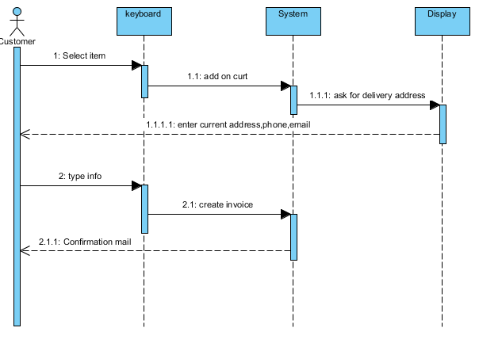

**Figure 7.5: Delivery Information of Sequence Diagram**

Use Case: Bill pay

Primary Actors: Customer

Courier boy

Precondition: Network connection is active.

Basic flows:

1. Customer will receive product

2. Corier boy will ask to sign product received form

3. Customer will sign the form

4. Customer will pay the bill

Alternate flows:

1. If Courier boy don’t collect customer sign on pickup form, than customer can complain he/she didn’t get any product.He will get product again.

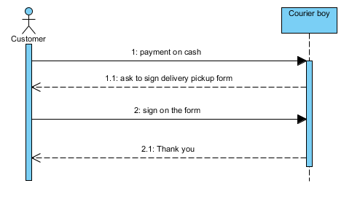

**Figure 7.6: Bill Pay Sequence Diagram**

Use Case: Product delivery

Primary Actors: Courier Boy  
 Customer

Precondition: Network connection is active.

Basic flows:

1. Courier boy will get new delivery job by email

2. Courier boy will collect delivery item from warehouse showing invoice

3. Courier boy will deliver product to customer

4. Customer will sign receive form & will paybill

5. Courier boy will collect bill with receiving form.

Alternate flows:

1. If customer invoice and Courierboy invoice is same than courier boy boy will deliver the product.

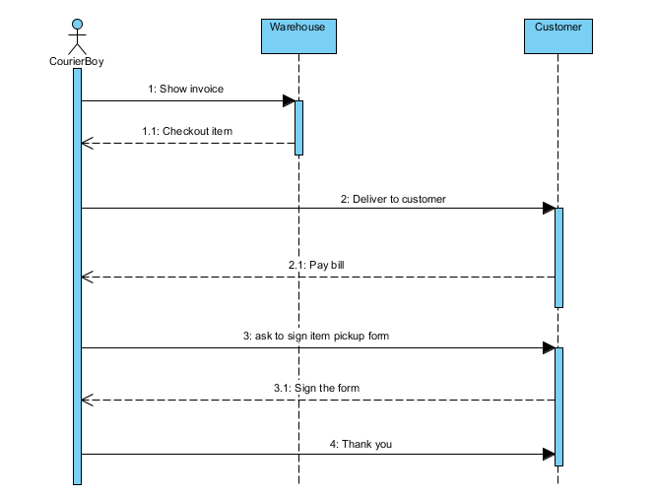

**Figure 7.7: Deliver Product Sequence Diagram**

Use Case: Submit collected bill

Primary Actors: Courier boy

Precondition: Network connection is active.

Basic flows:

1. Courier boy will show delivery received to submit payment

2. Finance will receive payment & entry the record

Alternate flows:

1. Cashier will collect all documents with payment, if any information or payment going wrong than Courier boy have to pay for this.

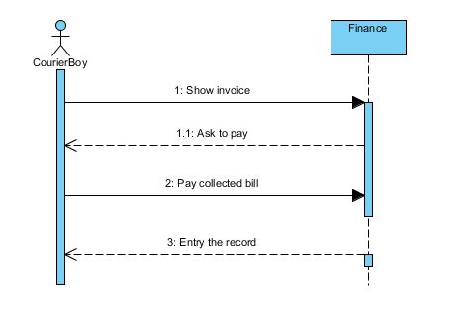

**Figure 7.8: Submit Collected Bill Sequence Diagram**

Use Case: Check order

Primary Actors: Manager

Precondition: Network connection is active.

Basic flows:

1. Manager will get email notification for new sells from system

2. Manager will check the selling record

3. Manager will permit to deliver product

4. If any problem found, than Manager will take step

Alternate flows:

1. Manager found any problem than he can take step.
2. Order must be approved by manager, otherwise warehouse never check out Product.

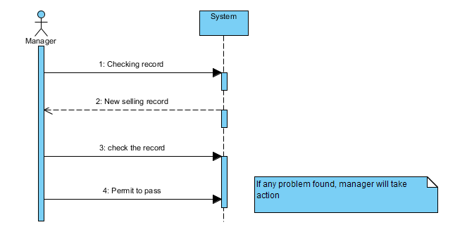

**Figure 7.9: Check Order Sequence Diagram**

Use Case: Add product

Primary Actors: Admin

Precondition: Network connection is active.

Basic flows:

1. Admin login to the System

2. System will ask for item name

3. Admin will submit Item name

4. System will ask for Item price

5. Admin will submit Item price

Alternate flows:

1. Without username & password or using wrong username & password admin can’t login.

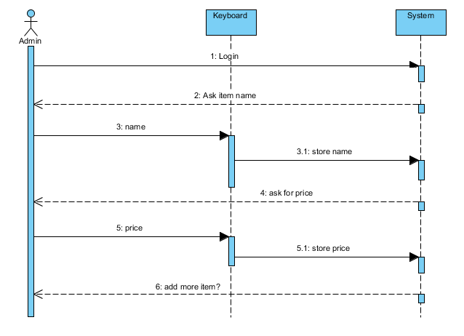

**Figure 7.10: Add Product Sequence Diagram**

Use Case: Update Product

Primary Actors: Admin

Precondition: Network connection is active.

Basic flows:

1. Admin will login to update Item information

2. System will ask for Item code

3. Admin will submit Item/Product code

4. System will ask to update information

5. Admin will update the Item information

Alternate flows:

1. Without Product code or using wrong product code admin cannot update Item.

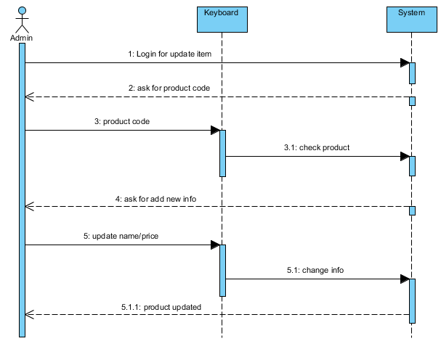

**Figure 7.11: Update Product Sequence Diagram**

Use Case: Delete Item

Primary Actors: Admin

Precondition: Network connection is active.

Basic flows:

1. Admin will login to delete Item/Product

2. System will ask to enter Item/Product code

3. Admin will enter code

4. System will delete the Item

Alternate flows:

1. Admin must have to be carefull to delete any product. Because if admin use any wrong product code other product can be deleted if code going match.

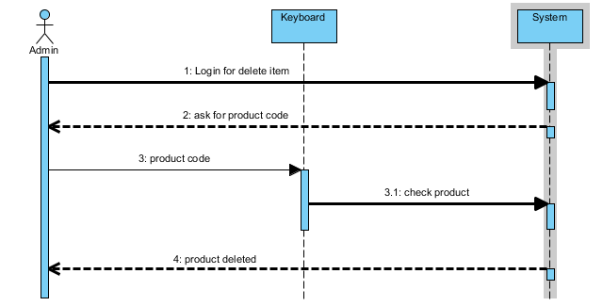

**Figure 7.12: Delete Product Sequence Diagram**

Use Case: Update User Information

Primary Actors: Admin

Precondition: Network connection is active.

Basic flows:

1. Admin will login to update user information

2. System will ask for username of user (I didn’t use user id. It is possible to use user id.)

3. Admin have to submit valid username

4. System will show update menu

5. Admin will update user information

Alternate flows:

1. If admin submit wrong username than system will reply to enter correct username.

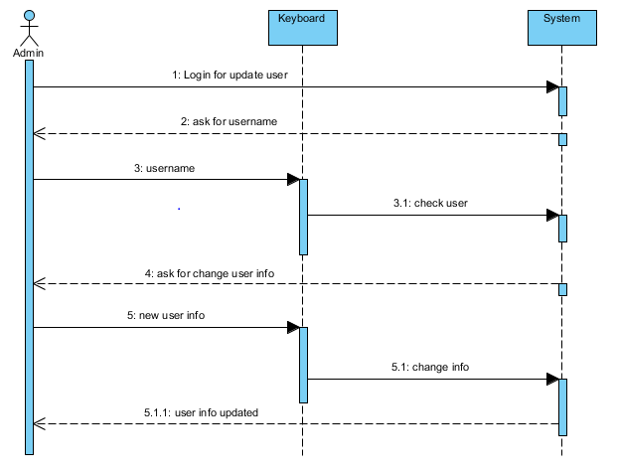

**Figure 7.13: Update User Sequence Diagram**

Use Case: Delete user

Primary Actors: Admin

Precondition: Network connection is active.

Basic flows:

1. Admin will login to delete user

2. System will ask for username of user (I didn’t use user id. It is possible to use user id.)

3. Admin have to submit valid username

4. System will delete the User

Alternate flows:

1. Admin must have to be carefull to delete any user. Because if admin use any wrong username other user can be deleted if code going match.
2. If username is not match than system will suggest to enter username again.

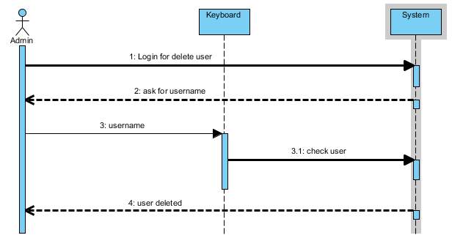

**Figure 7.14: Delete User Sequence Diagram**

**That was implemented using the following program:**

**Mongodb: User Information**

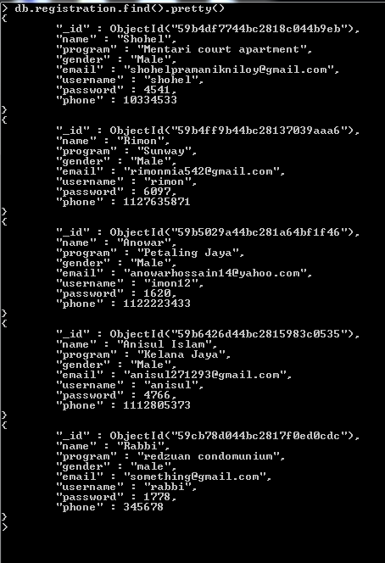

**Figure 8: User Information**

**SQL: Product Information**

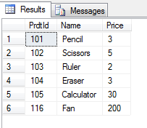

**Figure 9: Display Note Value**

**Microsoft Access: Financial Information**

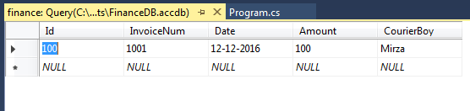

**Figure 10: Financial Record**

**TEST**

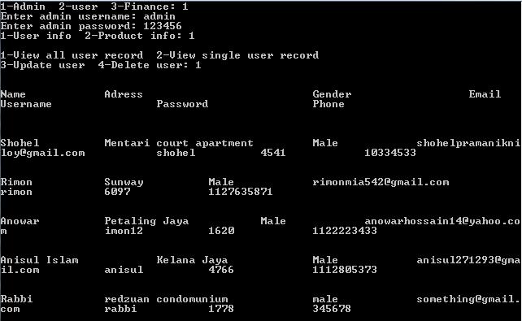

**Figure 11: View All User**

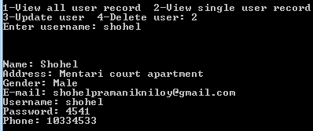

**Figure 12: View Single User**

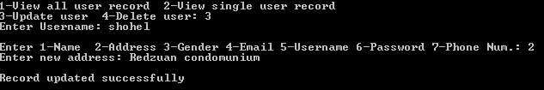

**Figure 13: Update User**



**Figure 14: Delete User**

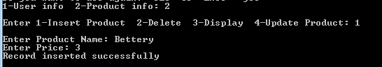 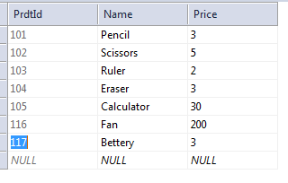

**Figure 15: Add Product**

 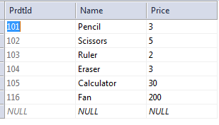

**Figure 16: Delete Product**

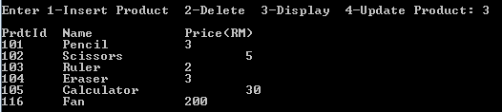

**Figure 17: Display Product Record**

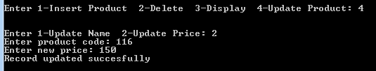

**Figure 18: Update Product Record**

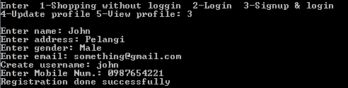

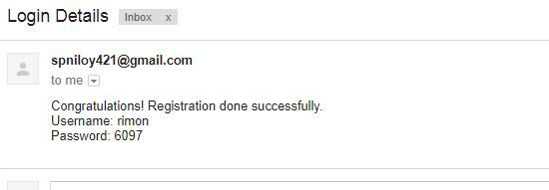

**Figure 19: Create User Account**

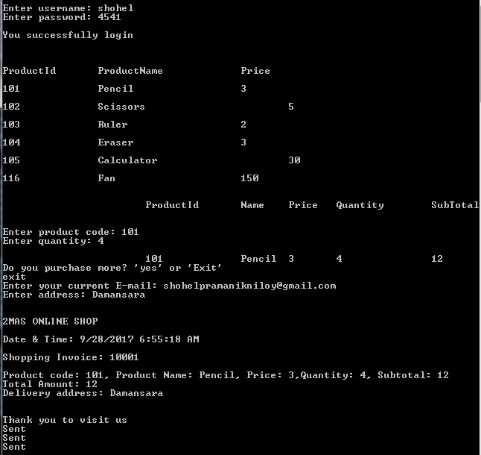

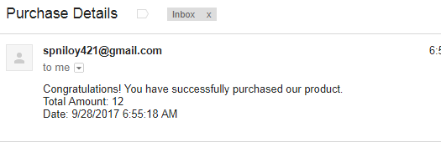

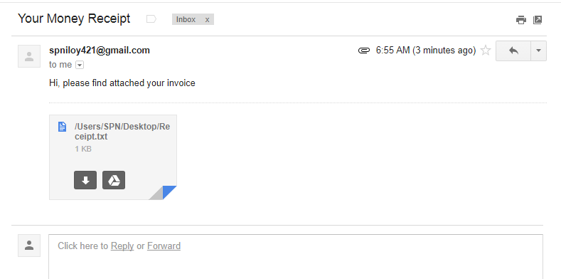

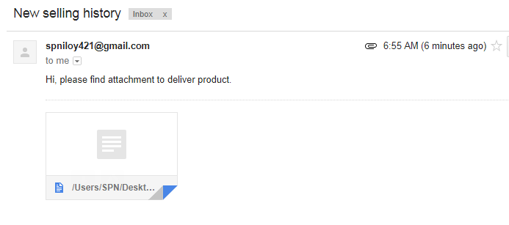

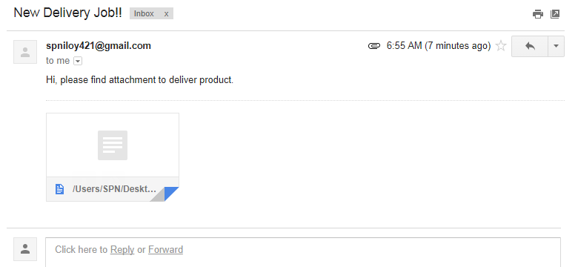

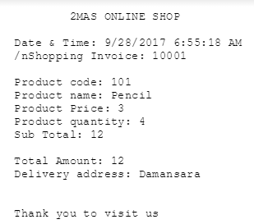

**Figure 20: Purchase Product**

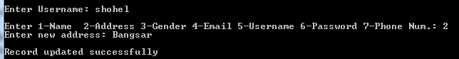

**Figure 21: Update user**

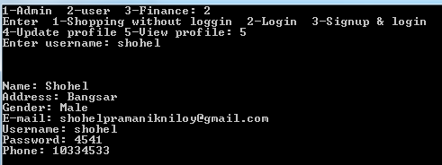

**Figure 22: View Profile**

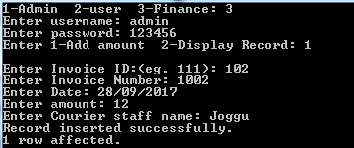 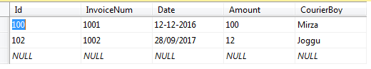

**Figure 23: Collect Payment**

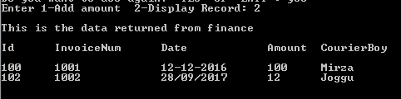

**Figure 24: View Financecial Record**

**CONCLUSION AND RECOMMENDATION**

Technology has made significant progress over the years to provide consumers a better online shopping experience and will continue to do so for years to come. With the rapid growth of products and brands, people have speculated that online shopping will overtake in-store shopping. While this has been the case in some areas, there is still demand for brick and mortar stores in market areas where the consumer feels more comfortable seeing and touching the product being bought. However, the availability of online shopping has produced a more educated consumer that can shop around with relative ease without having to spend a large amount of time. In exchange, online shopping has opened up doors to many small retailers that would never be in business if they had to incur the high cost of owning a brick and mortar store. At the end, it has been a win-win situation for both consumer and sellers.